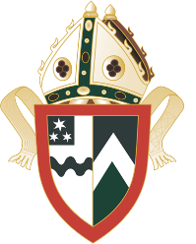
Waikato Diocesan Sporting success

Term 1

Futsal
In a first for Dio we took a team to compete in the NZSS Futsal Championships in Wellington. The team gained valuable learnings from this and look forward to competing in future years.

Sevens
Our Senior A team headed to Mount Maunganui to compete in the North Island Secondary Schools' Championships and came home with an outstanding fourth placing in this extremely competitive event. Congratulations also to Phoebe Tumata, Olivia Holten and Ava Dunn who were selected to represent Waikato in the U18 team at a recent tournament.

New Zealand Secondary Schools' Triathlon Championships
The NZSS Championships were held in New Plymouth and we gained some fantastic success results in the teams events. Congratulations to our U14 team on their Silver medal - Olivia Bayne, Emerson Wright and Estella Wainui-Mackle
Our U16 team came home with Gold. Well done to Charlize Tordoff, Nikita Coleman and Amelia de Lautour.
And, in the U18 age group, we again won Gold Congratulations Sarah Miller, Emma McKay and Ele Barton.
Congratulations also to Charli Herbert and Lucy Farrell who teamed up with St Peter’s Cambridge to win the U19 Tag Team event.

Tennis
At the inaugural New Zealand Secondary Schools' Tennis Cup Championships, which was held in Christchurch, our Dio team took out the top honours and won the event.
Well done to Saskia Johns, Zoe Clapcott and Emma Bartram on this wonderful achievement!

Rowing
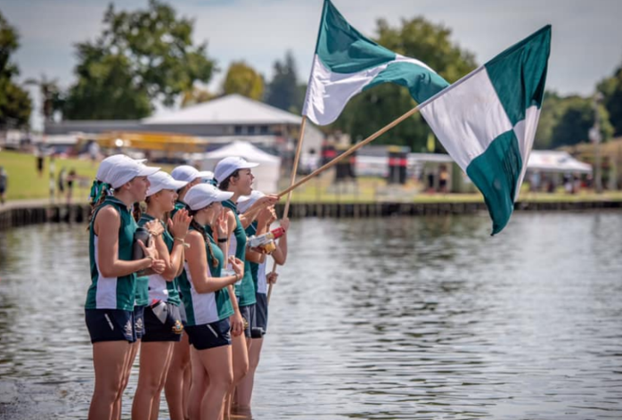
Our rowers gained some excellent results at the New Zealand Secondary Schools' Rowing Championships (Aon Maadi Cup) including finishing the regatta as Top Girls' School overall with 12 crews making A finals which puts them top 8 in the country for their event.
U18 8+ - Silver
Olivia Fellows-Ford, Sophie Reeves, Kate Monkley, Rosanna Bedford, Isobel Watson, Jessica Horrigan, Georgia Clapcott, Holly Mills and Pippa Wilson (Coxswain).
U18 4+ - Gold
Olivia Fellows-Ford, Sophie Reeves, Isobel Watson, Holly Mills and Pippa Wilson (Coxswain)
U18 Pair - Gold
Olivia Fellows-Ford and Holly Mills
U17 4+ - Bronze
Georgia Clapcott, Sophie Reeves, Isobel Watson, Rosanna Bedford and Pippa Wilson (Coxswain)
U16 4+ - Gold
Georgia Jefferis, Brooke Carter, Sophie Holten, Jessica Horrigan and Charlotte Grey (Coxswain)
A special mention to Holly Mills, Olivia Fellows-Ford and Isobel Watson who were all trialists for the New Zealand Junior team.
At the recent Waikato Rowing Club Prize-giving two of our Dio girls were recognised for their outstanding achievements this season. Pippa Wilson was awarded the Merv Waters Trophy for the Coxswain with the most points throughout the season and Holly Mills was awarded the Ron Cuff Memorial Trophy for the most promising youth rower. We are very proud of you both!

Water Polo
Our Senior A Water Polo were runners-up in the Waikato Secondary Schools' competition after an absolute nail biter with Hamilton Girls' High School. It was all level with only seconds left on the clock! What a game and we are so proud of our girls for this outstanding performance. A special mention to Sarah Jeffcoat who was named as one of two Most Outstanding Players from throughout the competition and Teri MacDonald who was named Most Valuable Player.
Our Senior Water Polo team competed at the NZSS Division 2 Championships in Rotorua during the holidays and after narrowly missing out on the top six they finished strong by winning the plate. Well done girls on a fantastic season!

Surf Lifesaving
Dio’s Milla Munro (Year 11) competed alongside 1200 athletes at the New Zealand Surf Lifesaving Championships held at Mount Maunganui Main Beach 22-24 March. The Year 11 student took out the NZ U16 Tube Rescue title and finished 4th in the NZ U16 Women’s Board Relay along with Ella Pomare and Lily Pearce. What an outstanding effort, Milla!

Sport Climbing
Congratulations to Zeta Hittmann who has been selected into the New Zealand Youth Sport Climbing Team 2019 in both lead a

Term 2

Water Polo
Congratulations to Teri MacDonald who has been selected into New Zealand's Under 18 Water Polo team!

Swimming
Congratulations to Laura Littlejohn who has been selected in the New Zealand Swimming team to compete at the 2019 Australian State Team Championships in October this year! An awesome recognition of Laura’s exceptional results.
Gina McCarthy is once again making us proud! She recently competed at the Aon New Zealand Open Championships in Auckland and successfully defended her 400m Individual Medley title.
A huge congratulations to Dio’s Laura Littlejohn, Amelia de Lautour, and Sarah Miller who swam in the 4 x 200 Freestyle Relay at the Aon NZ Swimming Opens, winning Bronze. Laura swam first and broke the Waikato record for 200m, Amelia the second leg, with Sarah bringing the team home.

Netball
The Monday Night Netball League is a six-week competition where our Open A, Senior Development and 10A1 come up against other Waikato Secondary Schools.
Congratulations to our 10A1 team on finishing as champions of the Year 10 grade! A fantastic achievement from this team. Our Open A and Senior Development both finished 3rd in their competitions.
Congratulations to our awesome Dio Netballers who have been selected into representative teams for this season.
Eastern Waikato
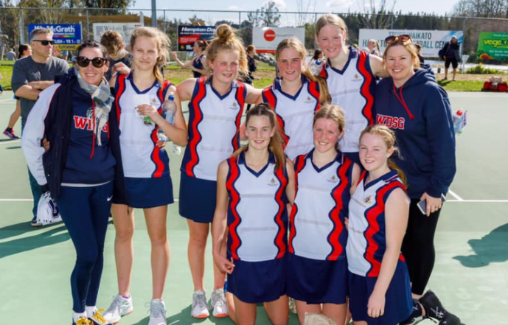
- U19A - Chelsea Whittaker
Hamilton City
- 9 Blue - Ava Karalus; Alexandra Peoples
- 9 Teal - Carys Foot
- U15A - Grace Wilson; Jessica Pyke
- U17A - Sophie Reeves
- U17B - Isabella Reid
- U19A - Phoebe Tumata
Te Awamutu
- VU15A - Xante Johnson

Squash
On 18 June, we took five girls to the Waikato Secondary Schools’ Individual Squash competition held in Cambridge. We gained some excellent results.
- Jenna Foot (Year 12) placed 2nd in Division 2.
- Carys Foot (Year 9) placed 2nd in Division 2.
- Kate Seager (Year 13) came away with the Special Plate also in Division 3.
Well done to those who competed, the team support was outstanding!

Cross-country
In the last Cross-country event before Nationals, our Dio girls gained some fantastic team results at the WaiBop Championships.
Senior Girls - 2nd in the 3 person
- Ele Barton, Emma Barton & Lucy Farrell
2nd in the 6 person
- Ele Barton, Emma Barton, Lucy Farrell, Zeta Hittmann, Emrick Garrett & Saskia Johns
U16 Girls - 2nd in the 3 person
- Bree Scott, Amelia de Lautour & Leah Norvall
1st in the 6 person
- Bree Scott, Amelia de Lautour, Leah Norvall, Estella Wainui-Mackle, Alexandria Endres & Tessa Smyth

NZSS Cross-country Championships
A Dio team of six runners traveled to Timaru to compete in the New Zealand Secondary Schools’ Cross-country Championships.
Results were:
- Ele Barton 30th; Emma Barton 57th; and Emrick Garrett 90th in Senior Girls’ 4km race. 11th in Team event.
- Bree Scott 21st; Alex Endres 75th in the Junior Girls’ 3km race.
- Alex Peoples 65th in the Year 9 race.

Equestrian
Our Equestrian team achieved some outstanding results at the North Island Secondary Schools' Horse Trials in Taupo.
- Waikato Dio Team 1, consisting of Samantha Caldwell, Tabitha Taylor, Georgia Wyatt, and Olivia Dunn placed 4th in the Level A category.
- Waikato Dio Team 2, consisting of Amelia Eagleton, Samantha Turnwald, Alice Buckley and Jess Wyatt placed 3rd in the Level AB category.
- Waikato Dio Team 3, consisting of Lena Hayes, Nicole Rogers, Leah Norvall and Caitlin Sharratt came 1st out of 34 teams for their combined dressage score!

Futsal
Congratulations to four of our Dio Senior Futsal team who have been selected in the WaiBOP Futsal Waikato Representative teams to attend the National Youth Futsal Championships in Wellington in July:
- Waikato U14 Girls - Tyla Tapp and Hayley Williams
- Waikato U16 Girls - Jordana Bremner
- Waikato U19 Girls - Rachel Major

Cycling
WSS Cycling Championship
- U19 2nd Elizabeth Chan; 3rd Emma Mckay
- U17 1st Olivia Gordan; 2nd Caitlyn Appel
- U16 2nd Nikita Coleman
- U15 3rd Emerson Wright

