Waikato Bay of Plenty Secondary Schools Cross Country Championships 2025
Venue: Waipuna Park, Tauranga
Date: Thursday, 7 August 2025 or (postponement date 14 August)
Host School: Tauranga Boys’ College
Course Description: Consists of 3 flat running areas separated by moderate downhill and uphill inclines to quite steep climbs. An all-grass surface (except for short, artificial grass road and path crossings) generally in firm condition Suitable for spikes, running flats or bare feet although 400m of the walnut grove needs care for barefoot runners and, if wet, can be slippery in the uphill/downhill sections.

Programme: 10.30 am Managers’ Meeting near the finish area
11.00 am Year 9 Girls 3000m (in year 9 and U15 on 31st Dec 2025)
11.20 am Year 9 Boys 3000m (in year 9 and U15 on 31st Dec 2025)
11.40 am Junior Girls (U16 on 31st Dec 2025) 3000m
12.00 pm Junior Boys (U16 on 31st Dec 2025) 4000m
12.00.pm Para boys (Y9/U16/U20 (ORS U22) on 31st Dec 2025) 2000m
12.25 pm Senior Girls (U20 on 31st Dec 2025) 4000m
12.25 pm Para girls (Y9/U16/U20 (ORS U22) on 31st Dec 2025) 2000m
12.50 pm Senior Boys (U20 on 31st Dec 2025) 6000m
Entries: This is an OPEN entry event – no qualification is required to compete other than that set by individual schools. Entries open on 14 July and close Monday 4 August 2025 and can be done online at https://enternow.co.nz/enternow-app/wsss . Please amend the entries previously made for 4 June and add any additional entries. The Entry charge will be $3.00 per athlete. Once you have completed your entries, you can download an Entry Confirmation. Schools will be invoiced $3 per participating athlete after the event.
Race bibs: Race bibs with timing chips will be issued for use on the day and placings will be taken electronically. Please return these bibs to the boxes supplied before athletes leave the recovery area.
Points: For teams races 3 person teams: The first three from each school count for team scores. 6 person teams: The first six from each school count for team scores. Schools can enter any number in each grade
Uniform: Ensure that your athletes come dressed and ready to run. Please wear the correct school athletics uniform as registered with WBOPSSA. The course is suitable for specialist cross country spikes and running shoes.

Facilities: Toilets are available. Please bring your own shelter if desired – there is space for tents. Food and Drinks will be available to purchase from Pippy’s Café located in the park.
Tidy up: Please bring rubbish bag/s to collect up your own athletes’ waste and take the bags with you for recycling and/or disposal. Ask your athletes to use the recycling and waste bins available (see site plan) and help with ensuring Waipuna Park is left in a tidy state please.
First Aid: All schools are asked to bring their own First Aid kits – ice will be provided.
Parking: Available in Waipuna car park and beside the kerbs of Kaitemako Road.

Upcoming events
NZSSAA Road Relay Festival, Pakuranga Sailing Club, Auckland, August 28-29
Day 1: INTER-SCHOOLS ROAD RELAYS EVENT – Thursday 28th August
Day 2: INTERPROVINCIAL REGIONAL ROAD RELAYS EVENT – Friday 29th August
All information can be found on the NZSSAA website at: newsletter-one.pdf
Entries for girls, boys and mixed teams of 4 runners open on Wednesday, July 23 and close Thursday, August 21 for school teams and Monday August 25 for provincial teams.

52nd NZSSAA Track, Field and Road Race Championships, Hastings, December 5-7
Entries for this event will open in mid October. Please watch for information appearing on the NZSSAA website or Facebook pages.

Course Map
Year 9 Girls/Boys, Junior Girls: Black then Red x 1 then Yellow to Finish, 3km total
Junior Boys, Senior Girls: Yellow then Red x 2 then Yellow to Finish, 4km total
Para Boys (start with Junior Boys): Yellow then Red x 2 then Yellow to Finish, 2km total
Para Girls (start with Senior Girls): Yellow then Red x 1 then Yellow to Finish, 2km total
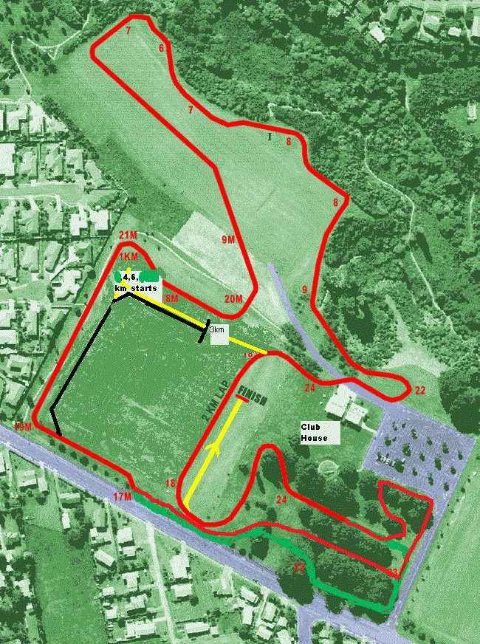
Senior Boys: Yellow then Red x 3 then Yellow to Finish, 6km total
Pippi’s Pantry recycling/waste bin
Council Recycling/Waste bins

